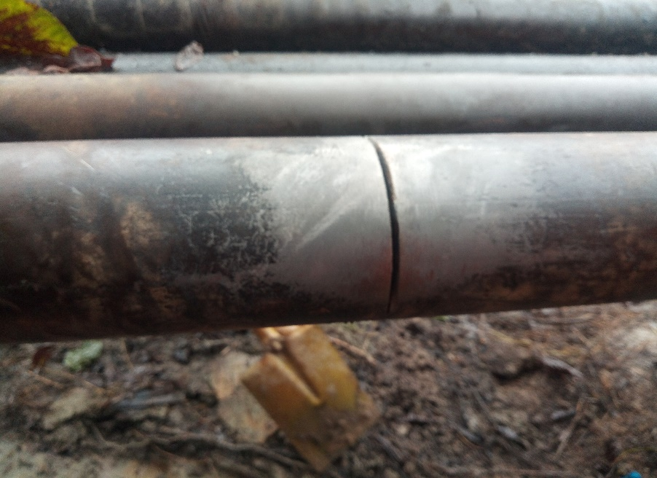

Figure 1. Arrow showing the spill point with hack saw cut

